Bom Liste

| **Billede** | **Mængde** | **Navn** | **Beskrivelse** | **Pris** | **Fabrikant** | **Datasheet** |
| --- | --- | --- | --- | --- | --- | --- |
|  | 1 | ESP-  WROOM-  32E | Micro  Controller | 45 kr. | Espressif | [Link](https://www.espressif.com/sites/default/files/documentation/esp32_datasheet_en.pdf) |
|  | 1 | Texas Instruments LM35 | Sensor | 56 kr. | (Fås af flere producenter) | [Link](https://www.ti.com/lit/ds/symlink/lm35.pdf) |
|  | 1 | L121B02 Sirai, Ventilrelæ | Ventilrelæ | 730 kr. | Sirai | [Link](https://www.aimfluid.nl/media/files/sirai/gpv/a/datasheet-sirai-l121-eng.pdf) |
|  | 1 | Raspberry Pi | Lille computer | 235  kr. | Raspberry Pi | Kan findes i bilag |
|  | 2 | 100 Nanofrarad | Kondensator | 1 kr. | (Fås af flere producenter) |  |
|  | 1 | 1 kilo Ohm modstand | Modstand | 1 kr. | (Fås af flere producenter) |  |
|  | 1 | FQPF30N06L | Mosfet | 4kr | (Fås af flere producenter) | [Link](https://www.mouser.com/datasheet/2/149/FQPF30N06L-244348.pdf) |

# Billede bilag, Bomliste:

## ESP32

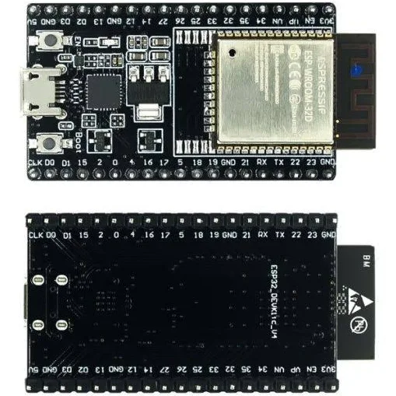

## LM35 sensor

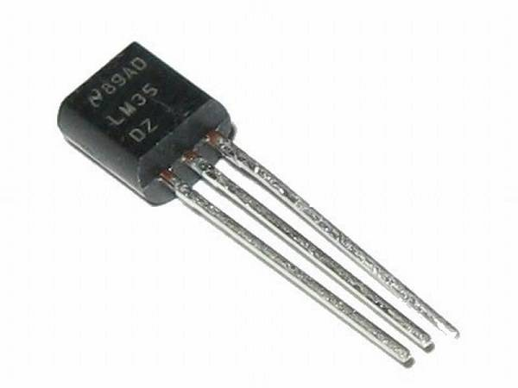

## Kabler

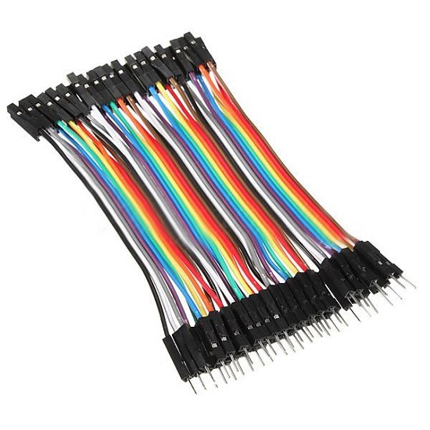

## Relæ Ventile

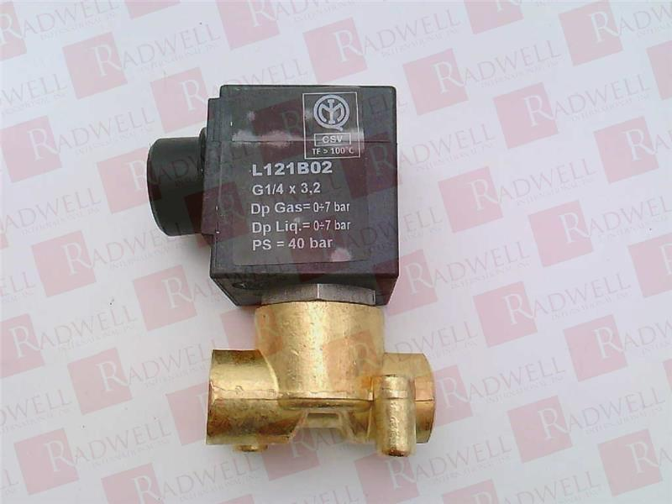

# FQPF30N06L

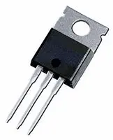

## RPI

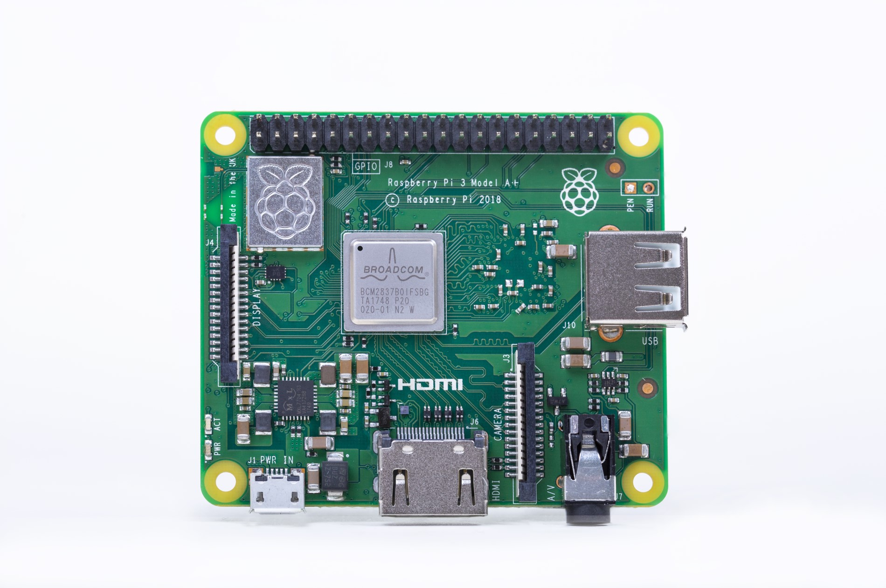

# SourceListe:

<https://www.electronicwings.com/sensors-modules/lm35-temperature-sensor> - LM35 sensor

<https://techbitshop.dk/vare/esp32-wroom-32d/> - ESP32

<https://www.radwell.co.uk/en-GB/Buy/SIRAI/SIRAI/L121B02-ZA10A%20G1-DIV-4%20X%203,2%2024-DIV-DC/?redirect=true> - Relæ ventile

<https://arduinotech.dk/shop/dupont-jumper-wire-1p-10cm/> - Dopuntkabler

<https://raspberrypi.dk/en/product/raspberry-pi-3-model-a-plus/> - RPI

<https://dk.ocean-components.com/product/AMI-Semiconductor-ON-Semiconductor_FQPF30N06L.aspx> - FQPF30N06L